Electoral College Activity
  - Electoral Vote vs Popular Vote
Objective: To examine the difference between the Electoral College and a popular vote as it would affect an election, for both the parties campaigning and the states.
Materials:
- States printout
- Map from 270 to win simulation based on registration data from 2010
- Pennies or paper clips (538 of them)
- 40 small slips of paper as ‘Campaign Promises’, 20 red and 20 blue. If you like, you or the students can write campaign promises on these pieces of paper, like “More jobs in your state!” or “I met a young family from your state, and we want to help them out with better health care.” It could seem a bit cynical, but it adds to the fun.
- Two jars, one with a red “R” and one with a blue “D”
- State population chart

Preparation:
Cut up the activity printout. The number of states you need is your class size -4, since four students will be candidates. The states are ordered so there is a variety of Electoral College votes and Party Affiliations, but feel free to choose the states you think represent the widest diversity for class size. Not all 50 states are represented.
Divvy the 538 pennies according to the map below, based on 2010 voter registration data, 275 in the D jar and 263 in the R jar. 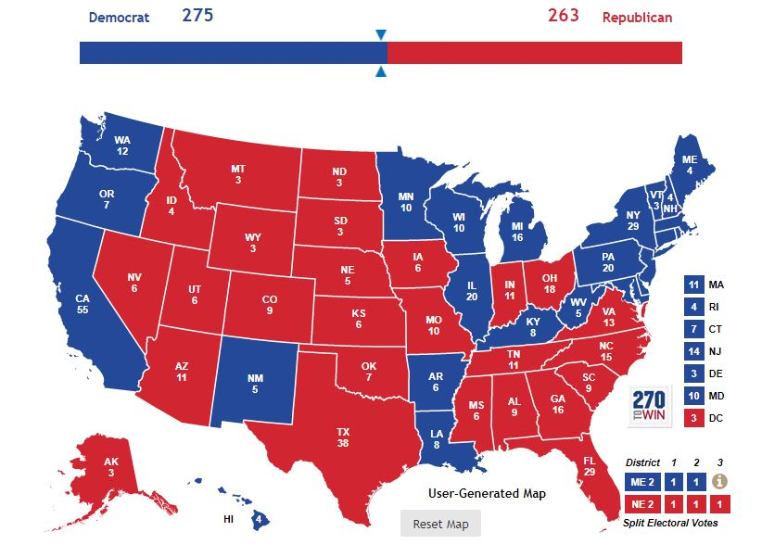
Procedure:
- Explain that this is a hypothetical election based on census data of state party affiliation from 2010, and a United States of America that has an exactly 50/50 split between Republicans and Democrats in the population.
- Explain that each state tends to favor one party over the other, and the state cards that are handed out display how much. For example, Texas says R 20%. That means that Texas favors the republican candidate 20% more that it does the Democratic candidate.
- Place the two prepared jars of pennies on a table. Show them the above map if you wish, explain that the Republicans start out with 263 electoral votes and the Democrats 275.
- Pick four students to be two sets of presidential candidates and their running mates; one democratic ticket and one republican ticket.
- Give each pair 20 slips of paper matching their party (Blue to the democrats, red to the GOP)
- Give each remaining student a state from the printout. If you have a smaller group, students can take 2 states.
- Each student with a state should go to the jars and remove the number of pennies equal to their electoral votes from the jar that matches their affiliation.
- The candidates and their running mates walk around the room examining how many electoral votes each state has, as well as the party affiliation percentage.
- After examining the field, the candidates huddle with their running mates to decide how they will spend their 20 Campaign Promises. Each one changes the party affiliation of a state 5% in their favor.
- The candidates write on a piece of paper how their 20 Campaign Promises will be spent. Once all choices are made, the candidates show the state the amount they pledged and give them the respective number of slips.
- Now it’s time to tally the votes! Many of the states will have received no Campaign Promises, and they just put their pennies in the jars that correspond with their party affiliation on their state. Each state that received Campaign Promises alters their party affiliation accordingly, 5 points per promise. If both parties spend on the same state, just remove duplicates to find the net gain. It’s possible for each candidate to spend many on the same state, resulting in no change whatsoever! Those states put their pennies in the jar of the newly calculated affiliation. If any states tie, the winner is the original affiliation on the state card.
- Check the jars! Winner is declared! Congratulations are in order.
- The popular vote election is much faster, and requires no moving around.
- Give the candidates the State Population Chart. Each state shows how many votes 1 Campaign Promise changes. Have the candidates write a tally of where they’d spend their 20 campaign promises.
- Take the chart from both parties, cross out duplicates, multiply the number of remaining CPs by the state’s Change per CP, and add them up. Whoever changed the most votes is the winner! Example below:
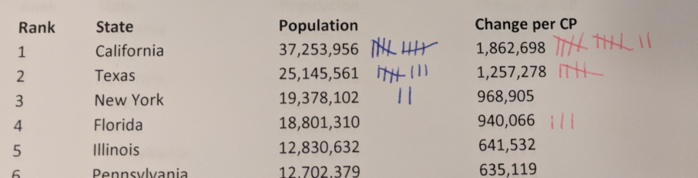
Here, the blue Democrats got a net of +3 in Texas, and +2 in NY. The Republicans got a net gain of +2 in California, and +3 in Florida. This alters the popular vote as such:
D: 3,771,843 (Texas) + 1,937,810 (NY) = 5,709,653
R: 3,725,396 (California) + 2,820,198 (FL) = 6,535,594
Republicans win the popular vote, by 825,941 votes!

Questions for discussion:
- Which system would you prefer as a voter? As a candidate?
- What are the downsides to the popular vote?
- If you lived in a small state, what could happen if we switched to a popular vote system? A large state?

